DeepStegAI
Data Flow Diagrams:
DFD Level - 0:
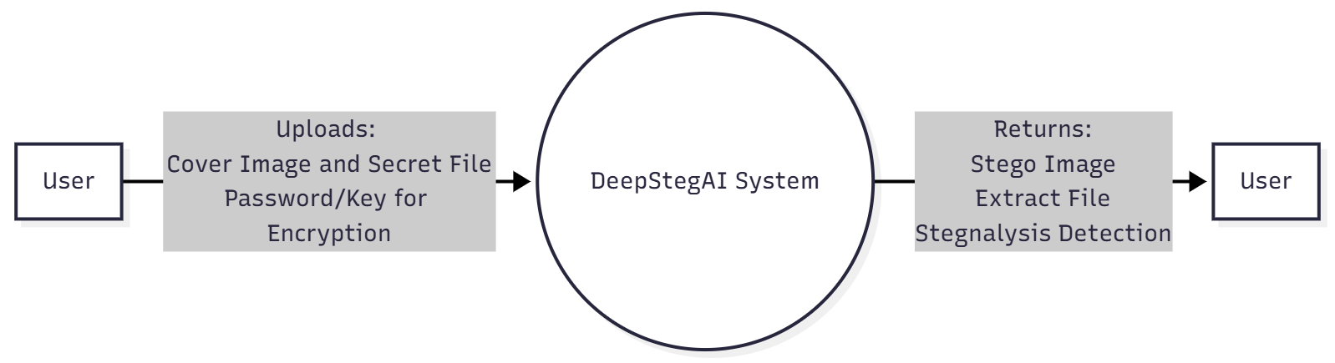
This diagram represents the Level 0 Context Diagram of DeepStegAI. It shows the interaction between the user and the DeepStegAI system. Users upload a cover image, secret file, and password. The system processes the request and returns stego image, extracted file, or steganalysis detection result.

DFD Level - 1
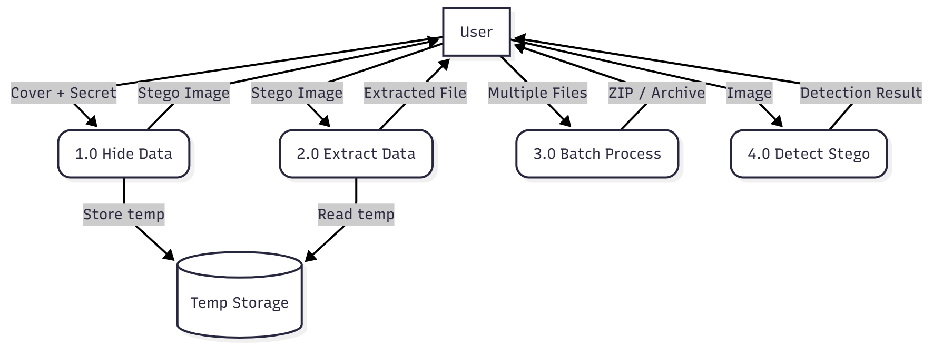
This Level 1 DFD explains the main functional modules of DeepStegAI: Hide Data, Extract Data, Batch Processing, and Detect Steganography. Temporary storage is used to store intermediate results securely.

DFD Level - 2

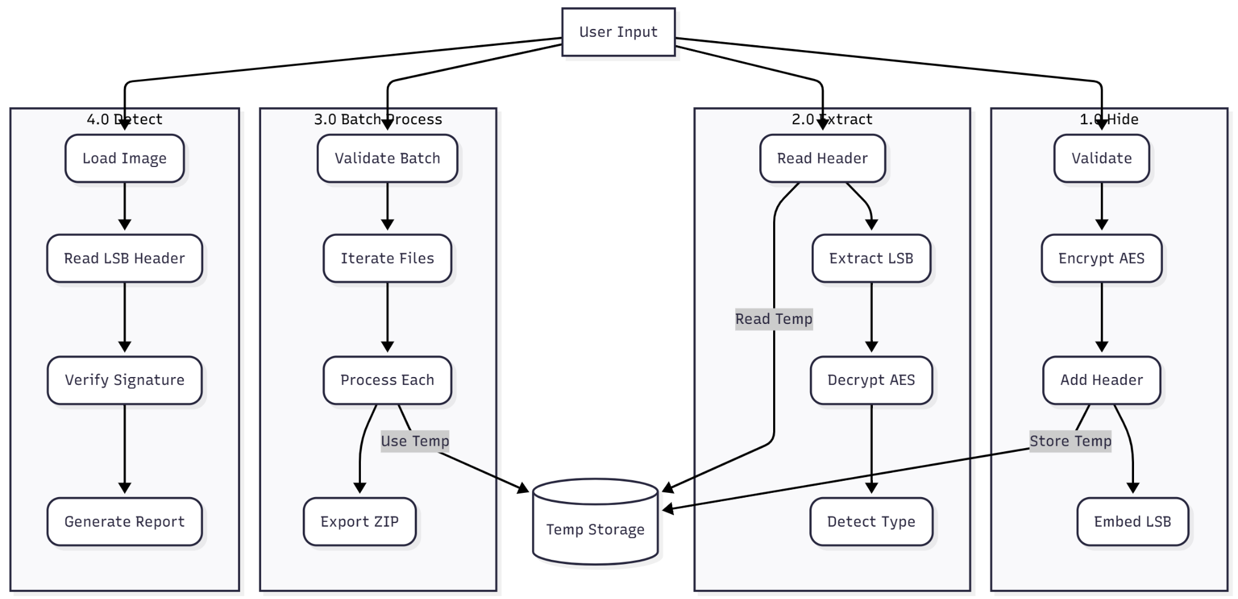
This detailed process flow shows internal logic of each module including validation, encryption (AES), LSB embedding, extraction, decryption, and signature verification. It illustrates how temp storage supports processing.

Use Case Diagram
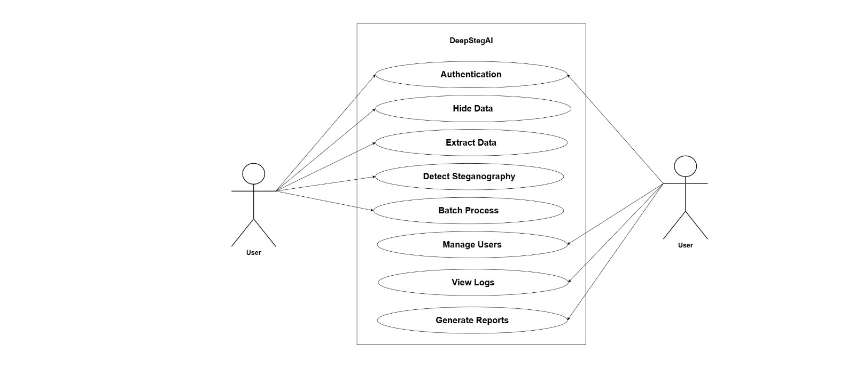
This Use Case Diagram presents system functionalities such as Authentication, Hide Data, Extract Data, Detect Steganography, Batch Processing, Manage Users, View Logs, and Generate Reports.
Swimlane Diagram
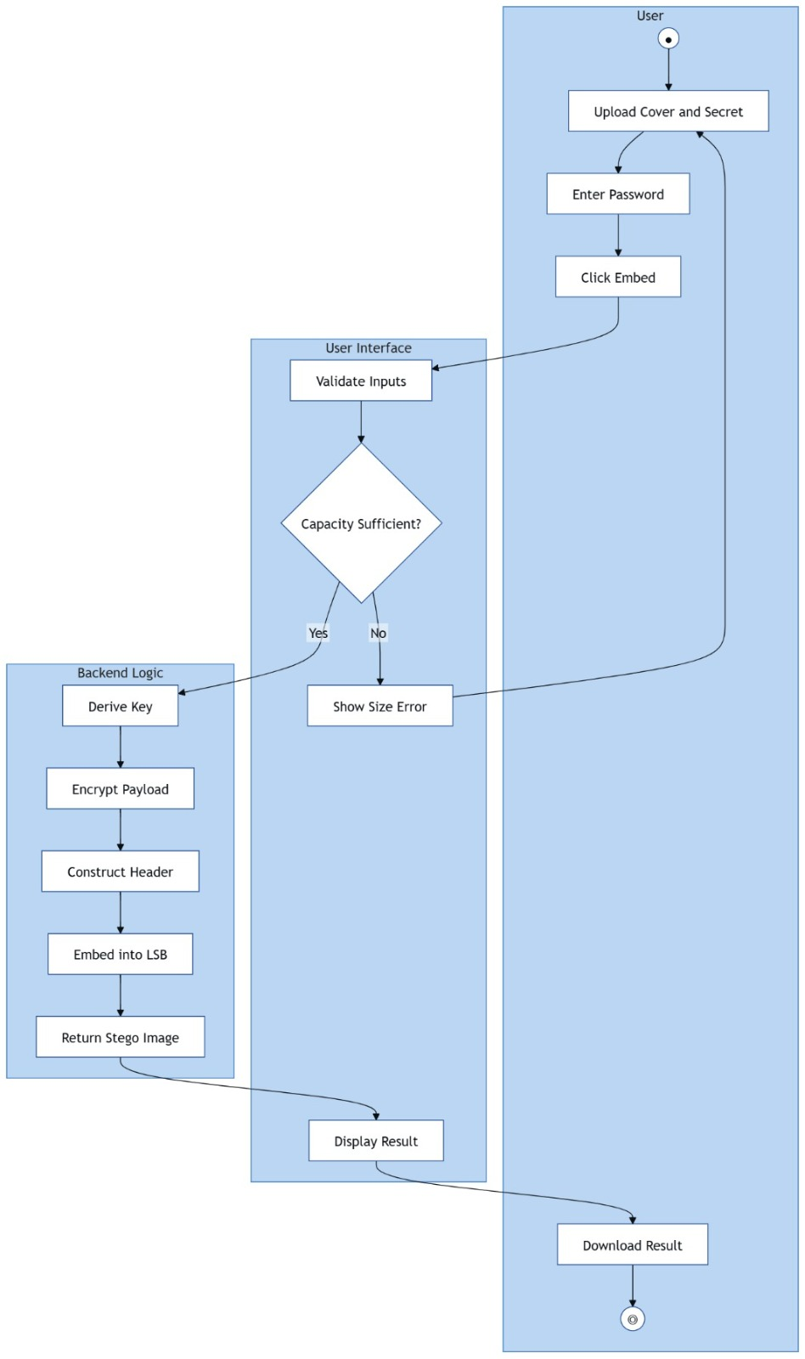
This Activity Diagram describes the step-by-step workflow of hiding data: uploading files, validating capacity, encrypting payload, embedding into LSB, and downloading result.
State Diagram
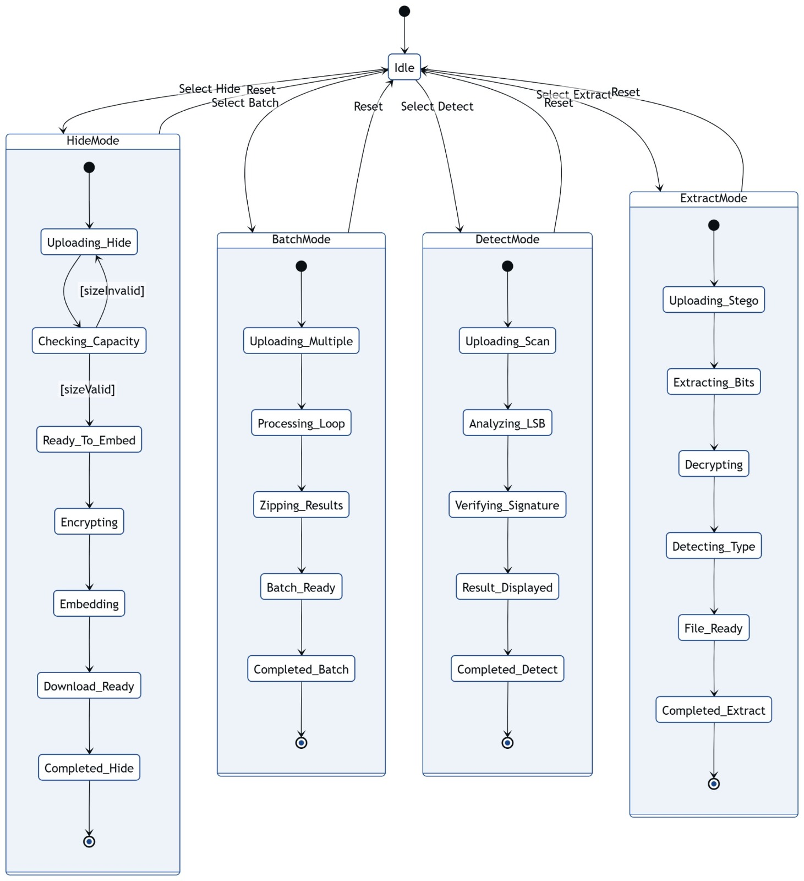
This State Machine Diagram represents different operational states such as HideMode, ExtractMode, BatchMode, and DetectMode. It shows transitions between idle and processing states.

ER Diagram
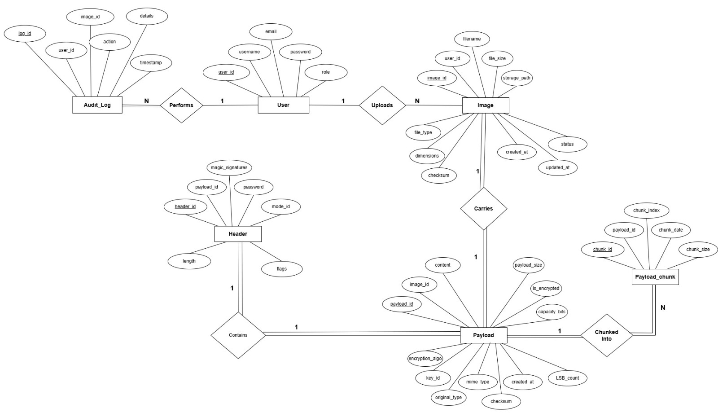
This ER Diagram models database structure including User, Image, Payload, Header, PayloadChunk, and AuditLog entities. It defines relationships such as uploads, performs, carries, and chunked into.

Class Diagram
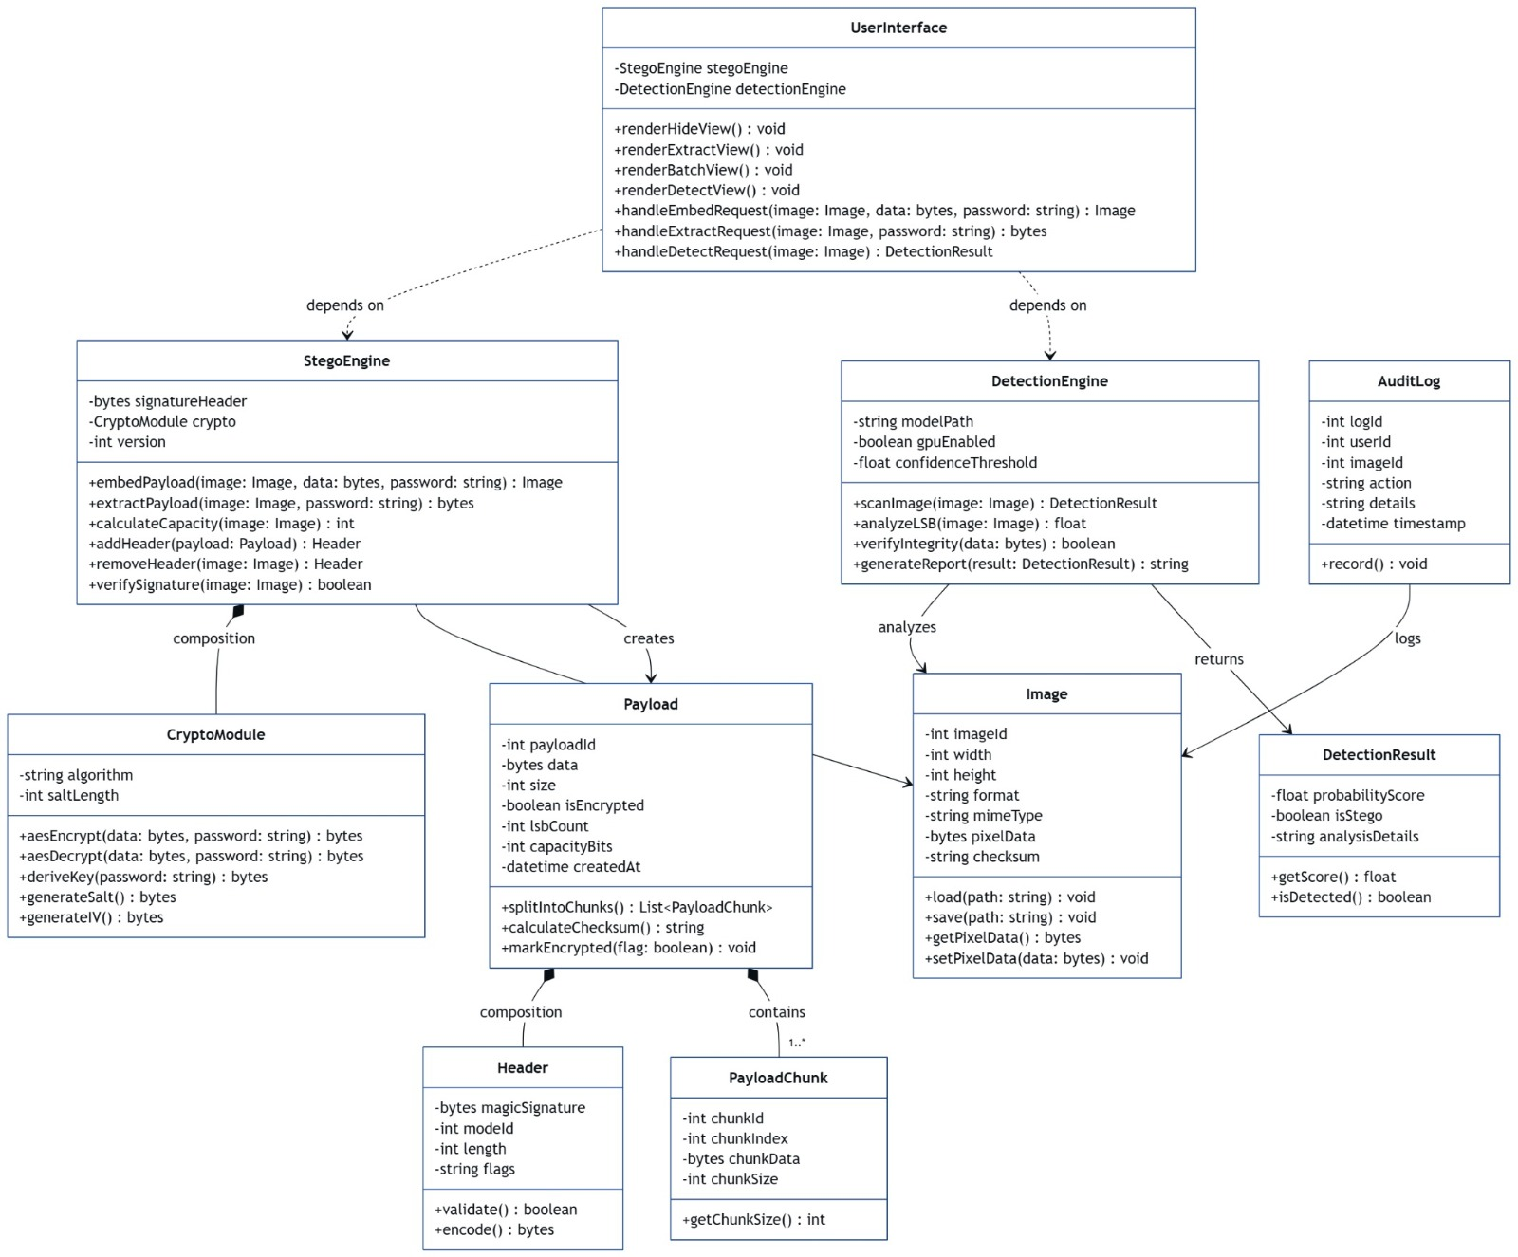
This UML Class Diagram explains software architecture components including UserInterface, StegoEngine, DetectionEngine, CryptoModule, Payload, Header, Image, and DetectionResult.

Architecture Diagram
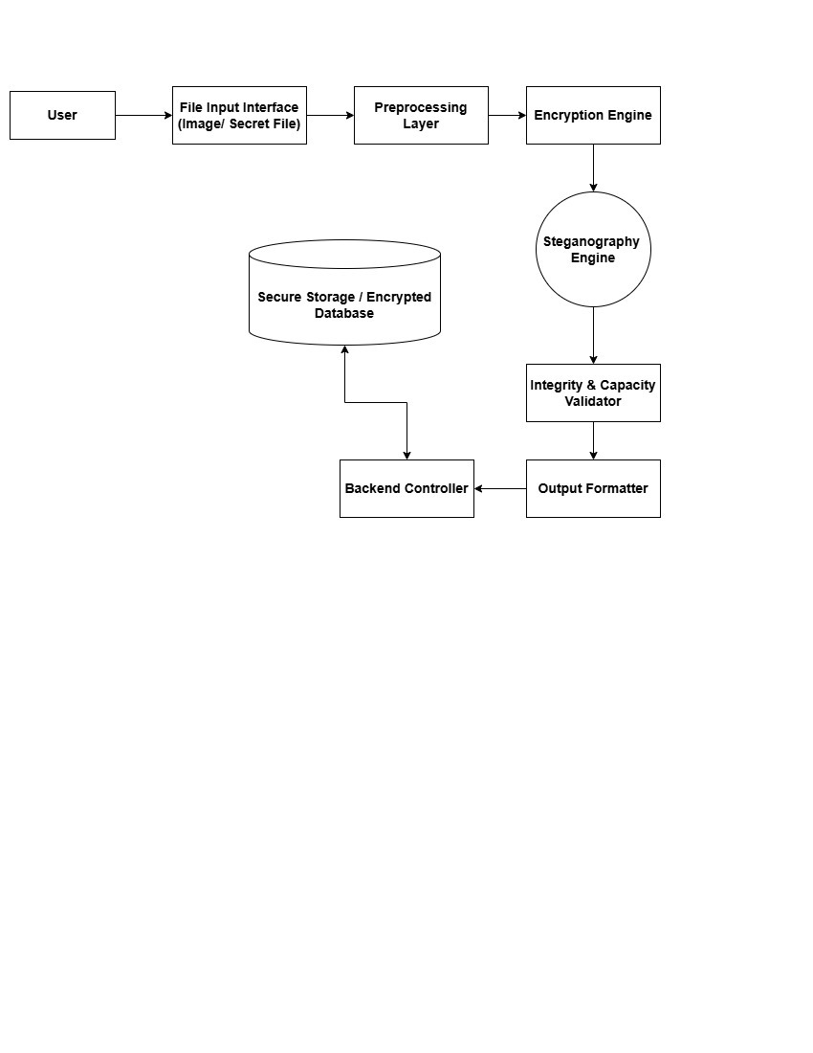
This System Architecture Diagram shows layered design: User Interface, Preprocessing Layer, Encryption Engine, Steganography Engine, Integrity Validator, Backend Controller, and Secure Storage.

